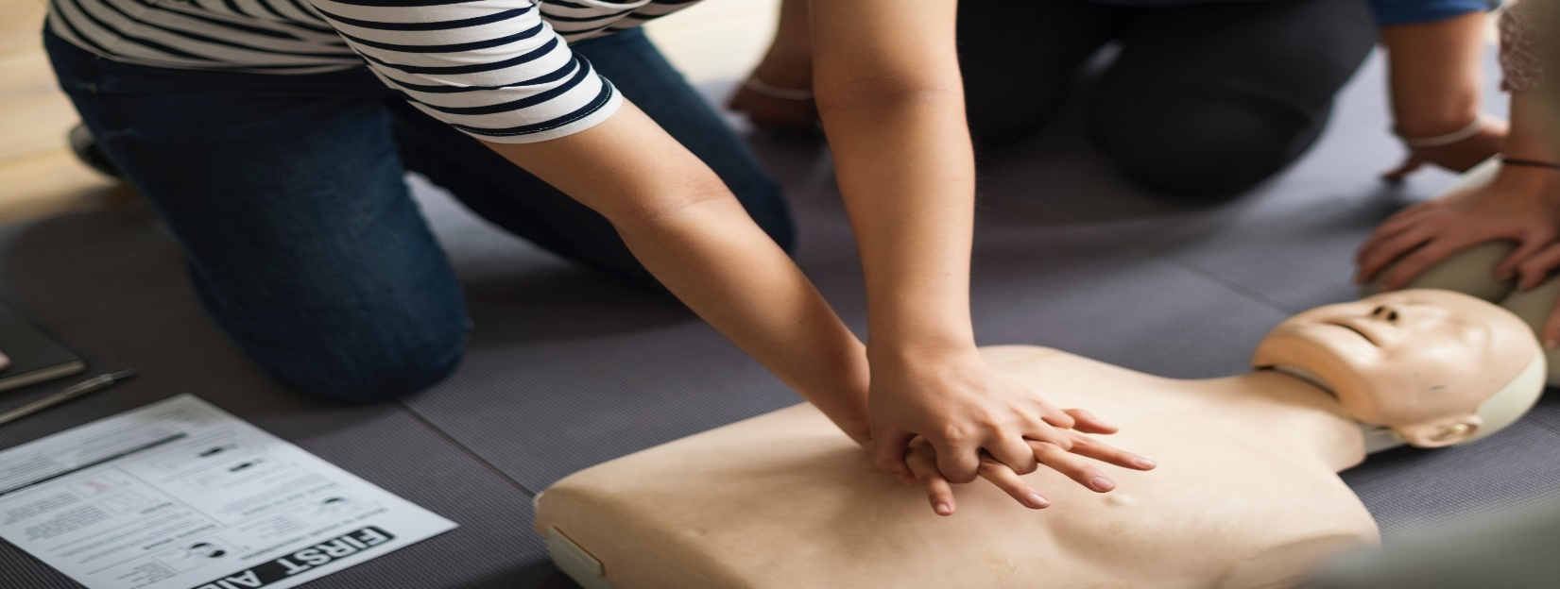

Medical assisting is a highly rewarding profession that provides some of the most flexible career opportunities in health care. The majority of medical assistants work in physicians’ offices, while the remainder are found in state, local and private hospitals and outpatient care centers. Depending on the facility you work in, you may be needed to work evenings, weekends or holidays. This is uncommon in a doctor’s office, but necessary at hospitals and healthcare facilities that are open 24 hours a day, seven days a week.

Work in the front office, completing a variety of administrative tasks. Or build your career on the clinical side, carrying out tasks that range from taking vital signs to counseling patients on medical procedures.

Here are six important job objectives you can expect to perform as a medical assistant!

- Build Relationships With Patients

Being a good listener falls among the most vital medical assistant duties. Whether they see a patient once a year or several times a month, medical assistants offer an understanding ear for patients going through routine doctor’s exams or struggling with chronic disease. Good medical assistants know when to talk, when to listen and how to match a patient’s mood or personality in their responses. The relationships they build with patients result in a positive influence on both the patient’s outlook and the medical office’s reputation.

- Update Patient Medical Records

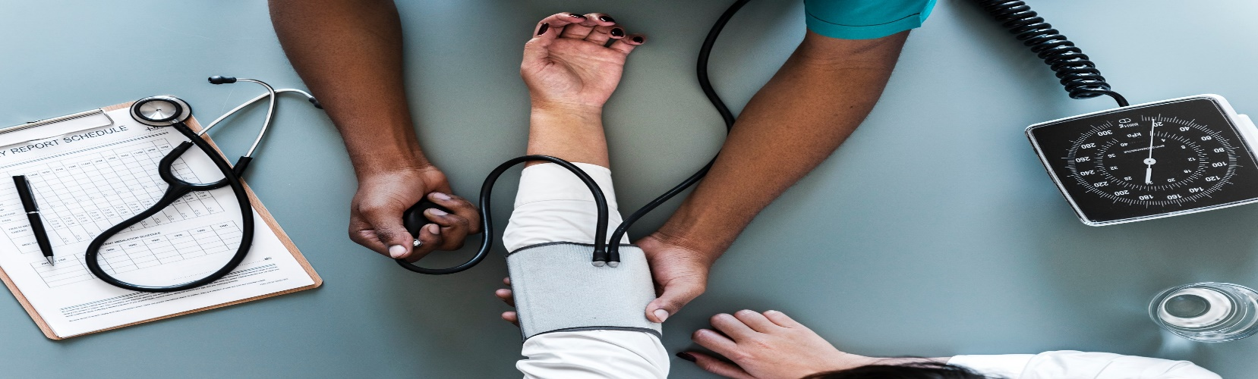

One of your most important tasks as a medical assistant is keeping patient medical records current. You will record a patient’s current weight and blood pressure, and key their pre-exam interview responses into a computer database. You may also be responsible for filing patient medical records, and adding written accounts from physicians or nurses based on exams and any lab tests.

- Prepare Exam Rooms

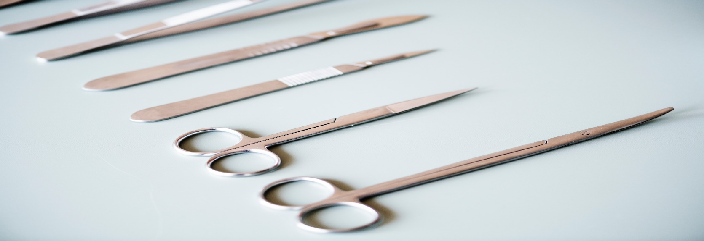

On the clinical side of medical assistant’s duties, preparing exam rooms is a top priority. This requires a number of steps, from disposing of contaminated supplies to sterilizing medical tools. Medical assistants might also perform the following tasks:
- Restock medical tools and equipment
- Arrange exam room instruments
- Set up lab trays necessary for a patient’s exam

- Manage Laboratory Tests and X-Rays

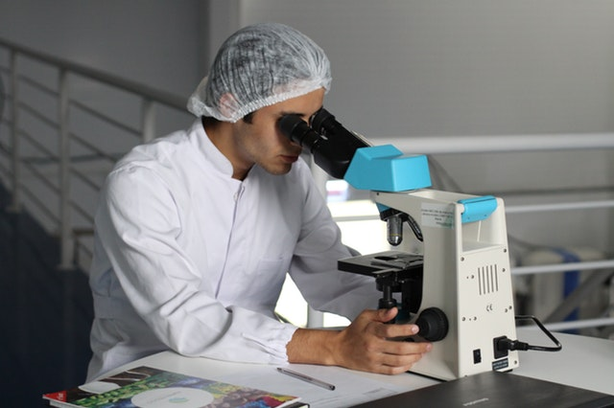

As a medical assistant, you will frequently arrange for laboratory services. Depending on their certification and employer, some medical assistants might collect and prepare lab specimens and perform basic lab tests. Further, many play a role in patient X-rays, as coordinators with the medical imaging team, or in assisting with X-ray preparation and development.
- Perform Routine Medical Tasks

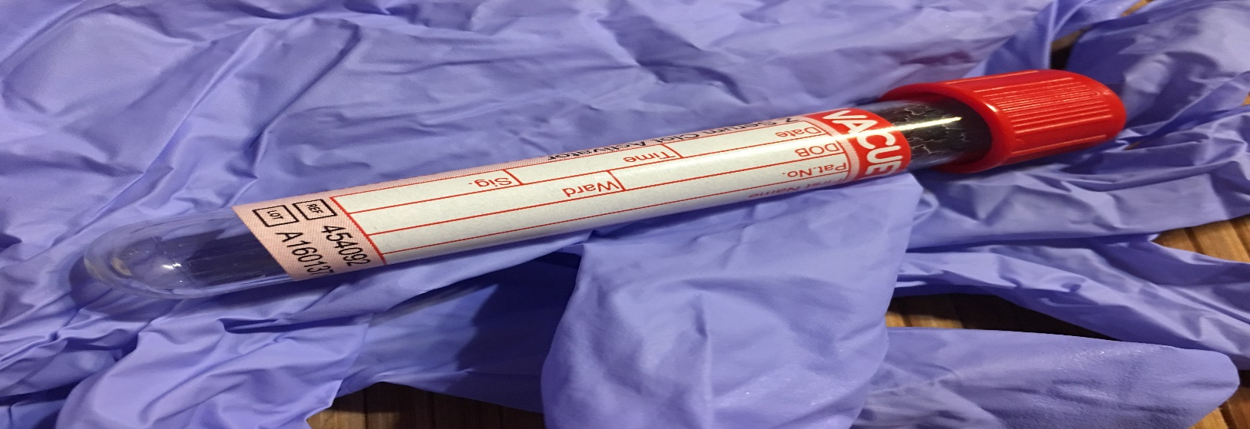

Drawing blood, delivering injections, administering medications, removing sutures, changing dressings—clinical medical assistants may complete any number of these tasks. In addition, you may explain medical procedures to patients and instruct them on dietary issues, medications and other areas relevant to their specific health condition.

- Use the Latest Technology

Healthcare technology is not what it used to be. More practices and healthcare facilities are moving from paper records to electronic health records (EHRs). Medical assistants entering the field should be prepared to manage patient’s records in a digital format. While it may take some getting used to if you are used to working with hard copies, you will find EHRs offer plenty of benefits, from real-time updates to streamlining communication between providers.
As a medical assistant, you will input patient information, such as diagnoses, medical history, treatment plans, test results and immunization dates, into a database. An EHR can be accessed (securely) from anywhere making it easier for multiple practitioners to see the same information.
Medical assistants should also be prepared for other evolving technology. These days, they communicate with patients via video and email. There is even an app for medical assistants preparing for professional certification exams.
Many medical assistants also use MEDITECH software, which provides modules such as patient discharge instructions and scheduling and referral management.

Specialized Medical Assistant Tasks

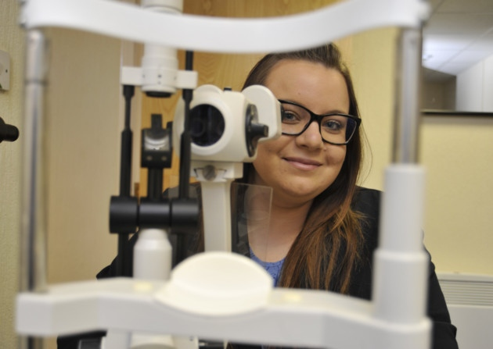

While the majority of medical assistants work in primary care, some specialize in a certain area of healthcare such as ophthalmology and podiatry. Many of the main tasks listed above will be part of your day, but you will also complete specialized duties:
Ophthalmology and optometry: Provide support to patients and demonstrate how to insert, remove and care for contact lenses.
Podiatry: You will assist by making castings of feet and developing x-rays. Medical assistants are often present during surgeries to provide help to the podiatrist.
Chiropractic: The tasks for a chiropractic medical assistant range from doing blood draws to performing certain therapies on patients, such as ultrasounds and traction.
OB/GYN: In this setting, you will help a physician care for women. Medical assistants often provide support during Pap exams and small surgeries.
If you decide to attend medical assistant school, participating in an externship in your preferred medical setting can offer plenty of benefits. You will gain hands-on experience and learn whether it is truly an area of medicine you enjoy.

All Allied Health Schools

