Z Score Plotting Exercises
Name: ________________________________ Date: __________________
Directions: For each exercise, mark the z-score or scores on the horizontal axis, shade the requested region, and calculate the probability. Round to four decimal places.

Part I Standard Normal Distribution
For Exercises 1-12, use mean = 0 and standard deviation = 1.

Left Tail Probabilities
1. Find P(Z < -2).
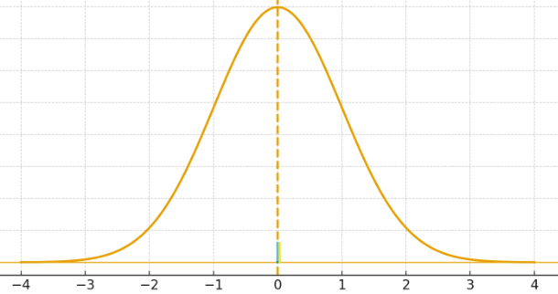
Probability: __________________________
2. Find P(Z < -1).
Probability: __________________________

3. Find P(Z < 1).
Probability: __________________________
4. Find P(Z < 2).
Probability: __________________________

Right Tail Probabilities
5. Find P(Z > -2).
Probability: __________________________
6. Find P(Z > -1).
Probability: __________________________

7. Find P(Z > 1).
Probability: __________________________
8. Find P(Z > 2).
Probability: __________________________

Probabilities Between Two Z Scores
9. Find P(-1.50 < Z < 1.56).
Probability: __________________________
10. Find P(-2 < Z < 2).
Probability: __________________________

11. Find P(-1 < Z < 1).
Probability: __________________________
12. Find P(0.50 < Z < 2).
Probability: __________________________

Using the Z Transformation
Use z = (x - mean) / standard deviation. Identify the mean and standard deviation, transform the raw score or scores, label and shade the curve, and calculate the probability.
13. Examination scores are normally distributed with a mean of 75 and a standard deviation of 8. Find P(X < 67).
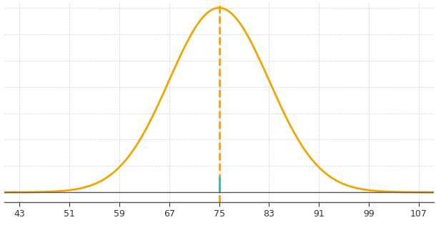
Z-score: __________________________
Probability: __________________________
14. Systolic blood pressures are normally distributed with a mean of 120 mmHg and a standard deviation of 15 mmHg. Find P(X > 150).
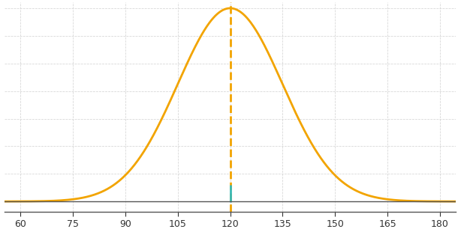
Z-score: __________________________
Probability: __________________________

15. The time required to prepare a medication is normally distributed with a mean of 12 minutes and a standard deviation of 3 minutes. Find P(9 < X < 15).
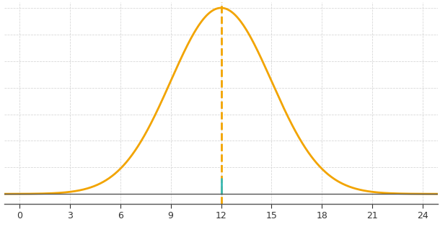
Lower z-score: ____________________ Upper z-score: ____________________
Probability: __________________________
16. Infant birth weights are normally distributed with a mean of 7.5 pounds and a standard deviation of 1 pound. Find P(X < 9).
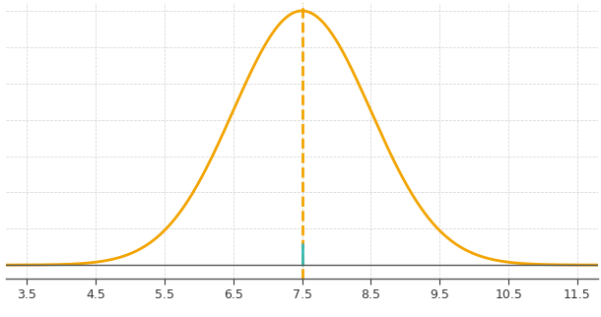
Z-score: __________________________
Probability: __________________________

17. Resting pulse rates are normally distributed with a mean of 72 beats per minute and a standard deviation of 12 beats per minute. Find P(X > 84).
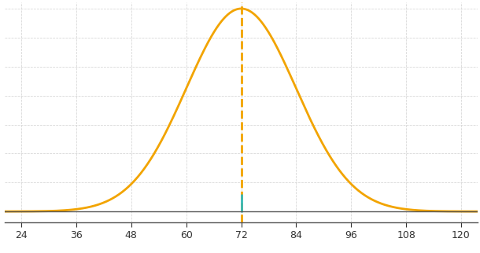

Z-score: __________________________
Probability: __________________________
18. Body temperatures are normally distributed with a mean of 98.2 degrees Fahrenheit and a standard deviation of 0.6 degree. Find P(97.0 < X < 99.4).
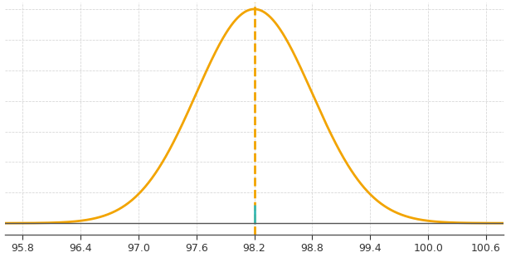
Lower z-score: ____________________ Upper z-score: ____________________
Probability: __________________________

19. Patient completion times are normally distributed with a mean of 40 minutes and a standard deviation of 5 minutes. Find P(X < 47.5).
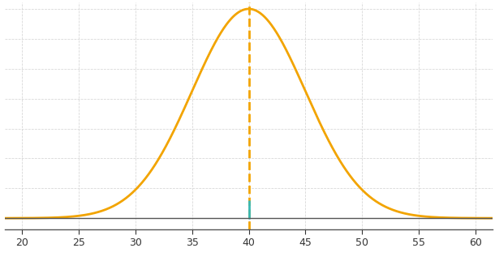
Z-score: __________________________
Probability: __________________________
20. Blood glucose measurements are normally distributed with a mean of 100 mg/dL and a standard deviation of 10 mg/dL. Find P(85 < X < 120).
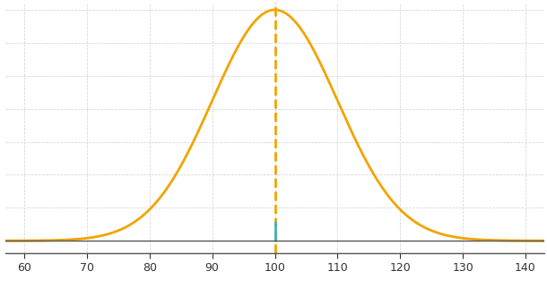
Lower z-score: ____________________ Upper z-score: ____________________
Probability: __________________________

