TROUBLE SHOOTING METHOD

PROCESS OF ELIMINATION

TROUBLE SHOOTING METHOD

PROCESS OF ELIMINATION

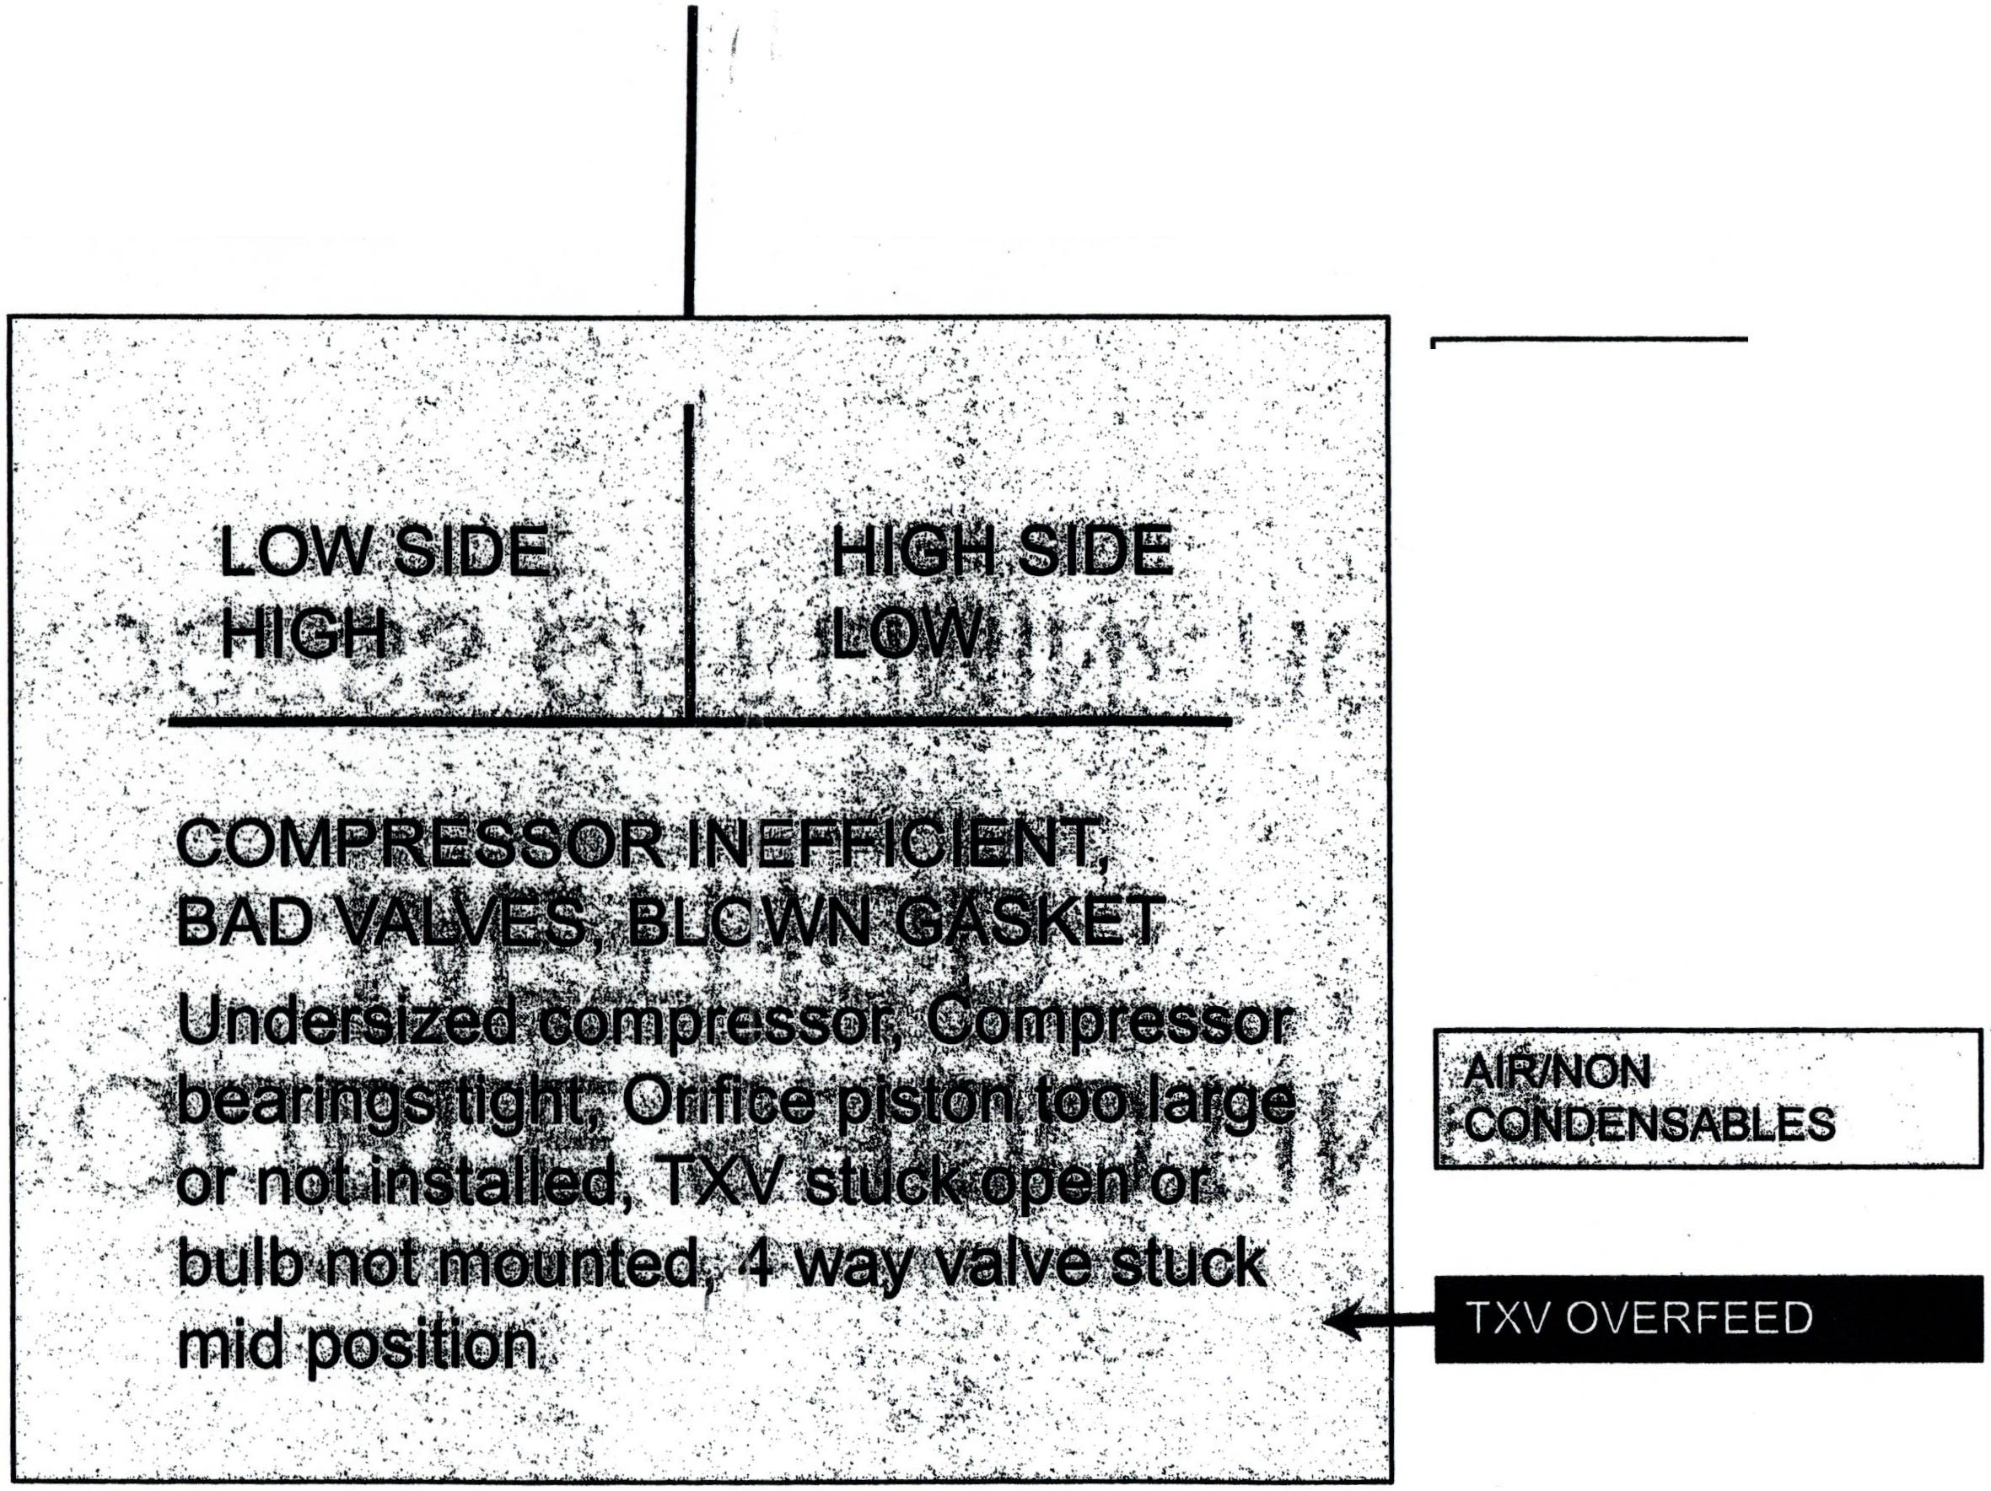
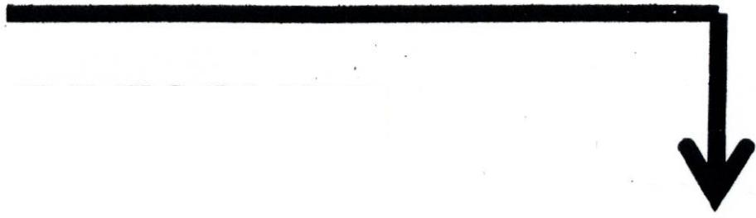
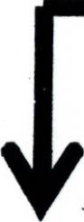
LOW PRESSURE
PROBLEMS
HIGH PRESSURE
PROBLEMS
LACK OF
CONDENSER AIR
FLOW
Sk.rcr
tiot
HIGH HEAT LOADOlk
OVERCHARGE$²_{co}^{u}
LIGHT EVAPORATOR
LOAD
UNDERCHARGE
LIQUID LINE RESTRICTION
LOW SIDE
RESTRICTION

GENERAL CONDITIONS ACCORDING TO THE TYPE OF
cm=cci IRP ARNnRMALITY Typical subcooling 8-15, S-heat 6-12 ,

HIGH PRESSURE PROBLEMS
- A high pressure problem exists when both high and low side pressures are higher than the established perfect cycle or manufacturer specification for pressure referenced by indoor load and outdoor ambient conditions.
- A typical perfect cycle for pressure is considered to be a pressure equal to 40 degrees F for the Low side and a temperature equal to outdoor ambient temperature plus 30 degrees for the high side.
- These conditions may vary depending on the age and SEER rating of the machine.
The following slides will deal with the general causes of high pressure and associated symptoms.

LACK OF CONDENSER AIR FLOW
CAUSES:
- Dirty condenser
- Blocked by trash, debris, plants, etc.
- Condenser fan motor problems, i.e. worn bearings, overheating, wrong rpm, wrong direction
- Condenser fan blade incorrect pitch, out of position, out of balance
SYMPTOMS:
- High discharge and suction presures
- High condenser split (air in to air out)
- Low sub-cooling (liquid level in condenser low, heat rejection low)
- Liquid line hotter than normal
- Normal to low super heat (TXV metering device)
- Low evaporator split (return/supply air differential)
- Amp draw higher than normal (compressor may cycle on IP or HP)
The primary condition with the system is Lack of Heat Rejection

HIGH HEAT LOAD
The word "LOAD" always refers to the product or fluid being cooled and the Component which picks up the heat (Evaporator).
CAUSES:
- Open or disconnected return duct (common with flexible ducting)
- Air mixing dampers open too far or malfunctioning
- Duct elbow separation (roof top units)
- Air box cover off or open
- Indoor fan motor speed too fast (wrong speed selection )
SYMPTOMS:
- High suction and discharge pressures
- Low sub-cooling (low liquid in condenser)
- High super heat (caused by increased boiling rate in evaporator)
- Low evaporator split (return/supply stir differential)
- Liquid line hotter than normal
- High amp draw (compressor my cycle on IP or HP)
The primary condition is to much heat supplied to the Evaporator

OVERCHARGE
CAUSE:
- Technician inexperience (not properly trained)
SYMPTOMS:
- High suction and discharge pressures
- High condenser split (air in to air out)
- High sub-cooling (liquid level high in condenser)
- Low super heat (liquid level high in evaporator) Normal to low with TXVs
- Heavy sweating on suction line up to compressor
- Low evaporator split (return/supply air differential)
- High amp draw (compressor may cycle on IP or HP)
Primary condition is caused by too much refrigerant in the system (common in split AC systems and refrigeration equipment assembled in the field or when adding refrigerant to an operating system with a partial charge).

AIR/NON CONDENSABLES
This condition will have similar symptoms to lack of condenser air flow
CAUSE:
- Technician inexperience (lack of proper training)
- Improperly purging a manifold gauge set during installation
- Insufficient vacuum during evacuation before charging
- Adding refrigerant to a system that had a leak on the low side
SYMPTOMS:
- High suction and discharge pressures
- High condenser split (split may be lower at top of condenser)
- Low sub-cooling (air in condenser will push liquid level down)
- Liquid line hotter than normal
- Normal to low superheat
- High amp draw (compressor may cycle on IP or HP)
- Static pressure does not match ambient temperature (higher than expected). A complete check of the system should conducted before relying on this information
Primary condition is that Air or Nitrogen is taking up space needed for the refrigerant and collecting in the top of the condenser reducing surface area necessary for normal heat rejection.

TXV/Metering overfeed
NOTE: An overfeed condition exists any time the evaporator has more refrigerant than normal. (Most High pressure conditions cause some overfeeding). When the metering device itself is causing the overfeed condition, the Suction pressure will he Higher than normal and the discharge pressure will be lower than normal.
To avoid confusion, the trouble shooting problems will be written as if the High side pressure will be higher than normal due to the fact that the overfeed may be due to a valve adjustment problem which could raise suction and discharge pressure
CAUSES: TXV stuck open, thernial bulb removed from suction line or not insulated, External equalizing line not connected, plugged or kinked. Piston orifice too large or missing.
SYMPTOMS:
- Suction pressure High, Discharge pressure (Low or High)
- Amp draw will depend on high side pressure condition
- Low super heat
- Compressor may be noisy due to flood back
- Low sub-cooling
I ^IA/ rawannratnr cnlit

LOW PRESSURE PROBLEMS
- A low pressure problem exists when both high and low side
pressures are lower than the established perfect cycle or manufacturer specification for pressure referenced by indoor load and outdoor ambient conditions.
- A typical perfect cycle for pressure is considered to be a pressure equal to 40 degrees F for the Low side and a temperature equal to outdoor ambient temperature plus 30 degrees for the high side.
- These conditions may vary depending on the age and SEER rating of the machine.
The following slides will deal with the general causes of low pressure and associated symptoms.

LIGHT EVAPORATOR LOAD
RULE: The existence of Lower than normal pressures accompanied by low superheat is an indication of Low air flow across the evaporator.
CAUSE:
- Dirty evaporator coil, air filter or fan wheel
- Loose fan wheel, loose belt, wrong'sized belt, pulley adjustment not correct
- Improper fan speed or fan rotation
- Collapsed ducting, supply registers closed down
SYMPTOMS:
- Low suction and discharge pressures
- Normal to high sub-cooling (TXV)
- Low superheat
- High split across the evaporator
- Low amp draw
- Sweating or frosted suction line up to the compressor
- Frosted evaporator coil (may cover entire coil)
- Slugging of compressor (noisy)

UNDERCHARGE
RULE: Low pressures accompanied by high superheat is an indication of a refrigerant flow problem (undercharge low sub-cooling, liquid line restriction high sub-cooling)
CAUSE:
- Technician inexperience (improper training)
- Refrigerant leaks
SYMPTOMS:
- Low suction and discharge pressures
- High superheat (low liquid level in evaporator)
- Low sub-cooling (Low liquid lever in condenser)
- Low amp draw (compressor may !cycle on IP or LP)
- Flashing in liquid line (bubbles in sight glass if installed)
- Frost line on coil at point of saturation
- Hissing and or spitting noise at metering device (severe undercharges)
The primary condition is lack of refrigerant needed for normal heat transfer in the evaporator.

LIQUID LINE/HIGH SIDE RESTRICTION
NOTE: For hot gas line restrictions, the head pressure will be high only when taken before the restriction and low downstream of the restriction. Suction pressure will always be low.
Causes:
- Object blockage in the line, damaged line (kinked or flattened)
- Wax, dirt, metal particles plugging strainer drier or meshed screen filters.
- Plugged or malfunctioning metering device (TXV bulb lost charge, ice due to moisture)
• Undersized metering device (TXV or piston orifice)
- Dama_ged or plugged distribution line to evaporator, distributor orifice too small (D(V)
• High side accessory malfunction (solenoid valve etc.)
Symptoms:
- Low suction and discharge pressures
- High superheat and high sub-cooling
- Frost or heavy sweating at point of restriction
- Pressure/temperature drop across restriction, bubbles in sight glass if located downstream of restriction
MAYO.. ic di i frl rpfrinprant flow

LOW SIDE RESTRICTIONS
NOTE: Pressure readings for low side will be high if taken before the restriction and low downstream of the restriction. High side pressure will always be low.
Causes:
- Installed suction filter drier is plugged (most common cause)
- Damaged suction line (kinked or flattened)
- Accessory malfunction (evaporator/crankcase pressure regulator)
Symptoms:
- Low /High suction with low discharge pressure
- Saturation temperature and pressure high in evaporator
- Sub-cooling higher than normal
- Suction pressure at compressor low and no frost or heavy sweating appearing anywhere
• An excessive pressure drop measured across suction drier or restriction
Primary condition is caused by a high backpressure in the evaporator as a result of restricted refrigerant flow in the suction line.

LOW SIDE PRESSUREHIGH/HIGH SIDE LOW
NOTE: This condition may be normal based on manufacturers perfect cycle for the unit based on SEER ratings which generally require lower head pressures and slightly higher suction pressures. The causes are sometimes difficult to narrow down.
Typical causes:
- Undersized compressor (compressor not matched during change out)
- Compressor has bad valves or other type of internal leakage (common)
- Compressor bearings are tight or motor not reaching rated rpm
- Reversing valve stuck in mid position
- Piston orifice metering device too large or not installed.
- TXV stuck open (uncontrolled overfeed)
Symptoms:
- High suction pressure, low discharge pressure
- Relatively normal superheat and sub-cooling for compressor problems
- Low superheat and low sub-cooling for uncontrolled overfeeds
Primary conditions are High backpressure and saturation temperature in the evaporator and/or High side pressure leaking back into low side

